CLASSIFICATION ALGORITHMS

USE INDEX AS UID MOD 2

INDEX 0: NAÏVE BAYES

INDEX 1: DECISION TREE

EVERY ONE WILL DO SUPPORT VECTOR MACHINE ALGORITHM USING PYTHON LIBRARIES

SELECT ANY DATASET OF YOUR CHOICE  
  
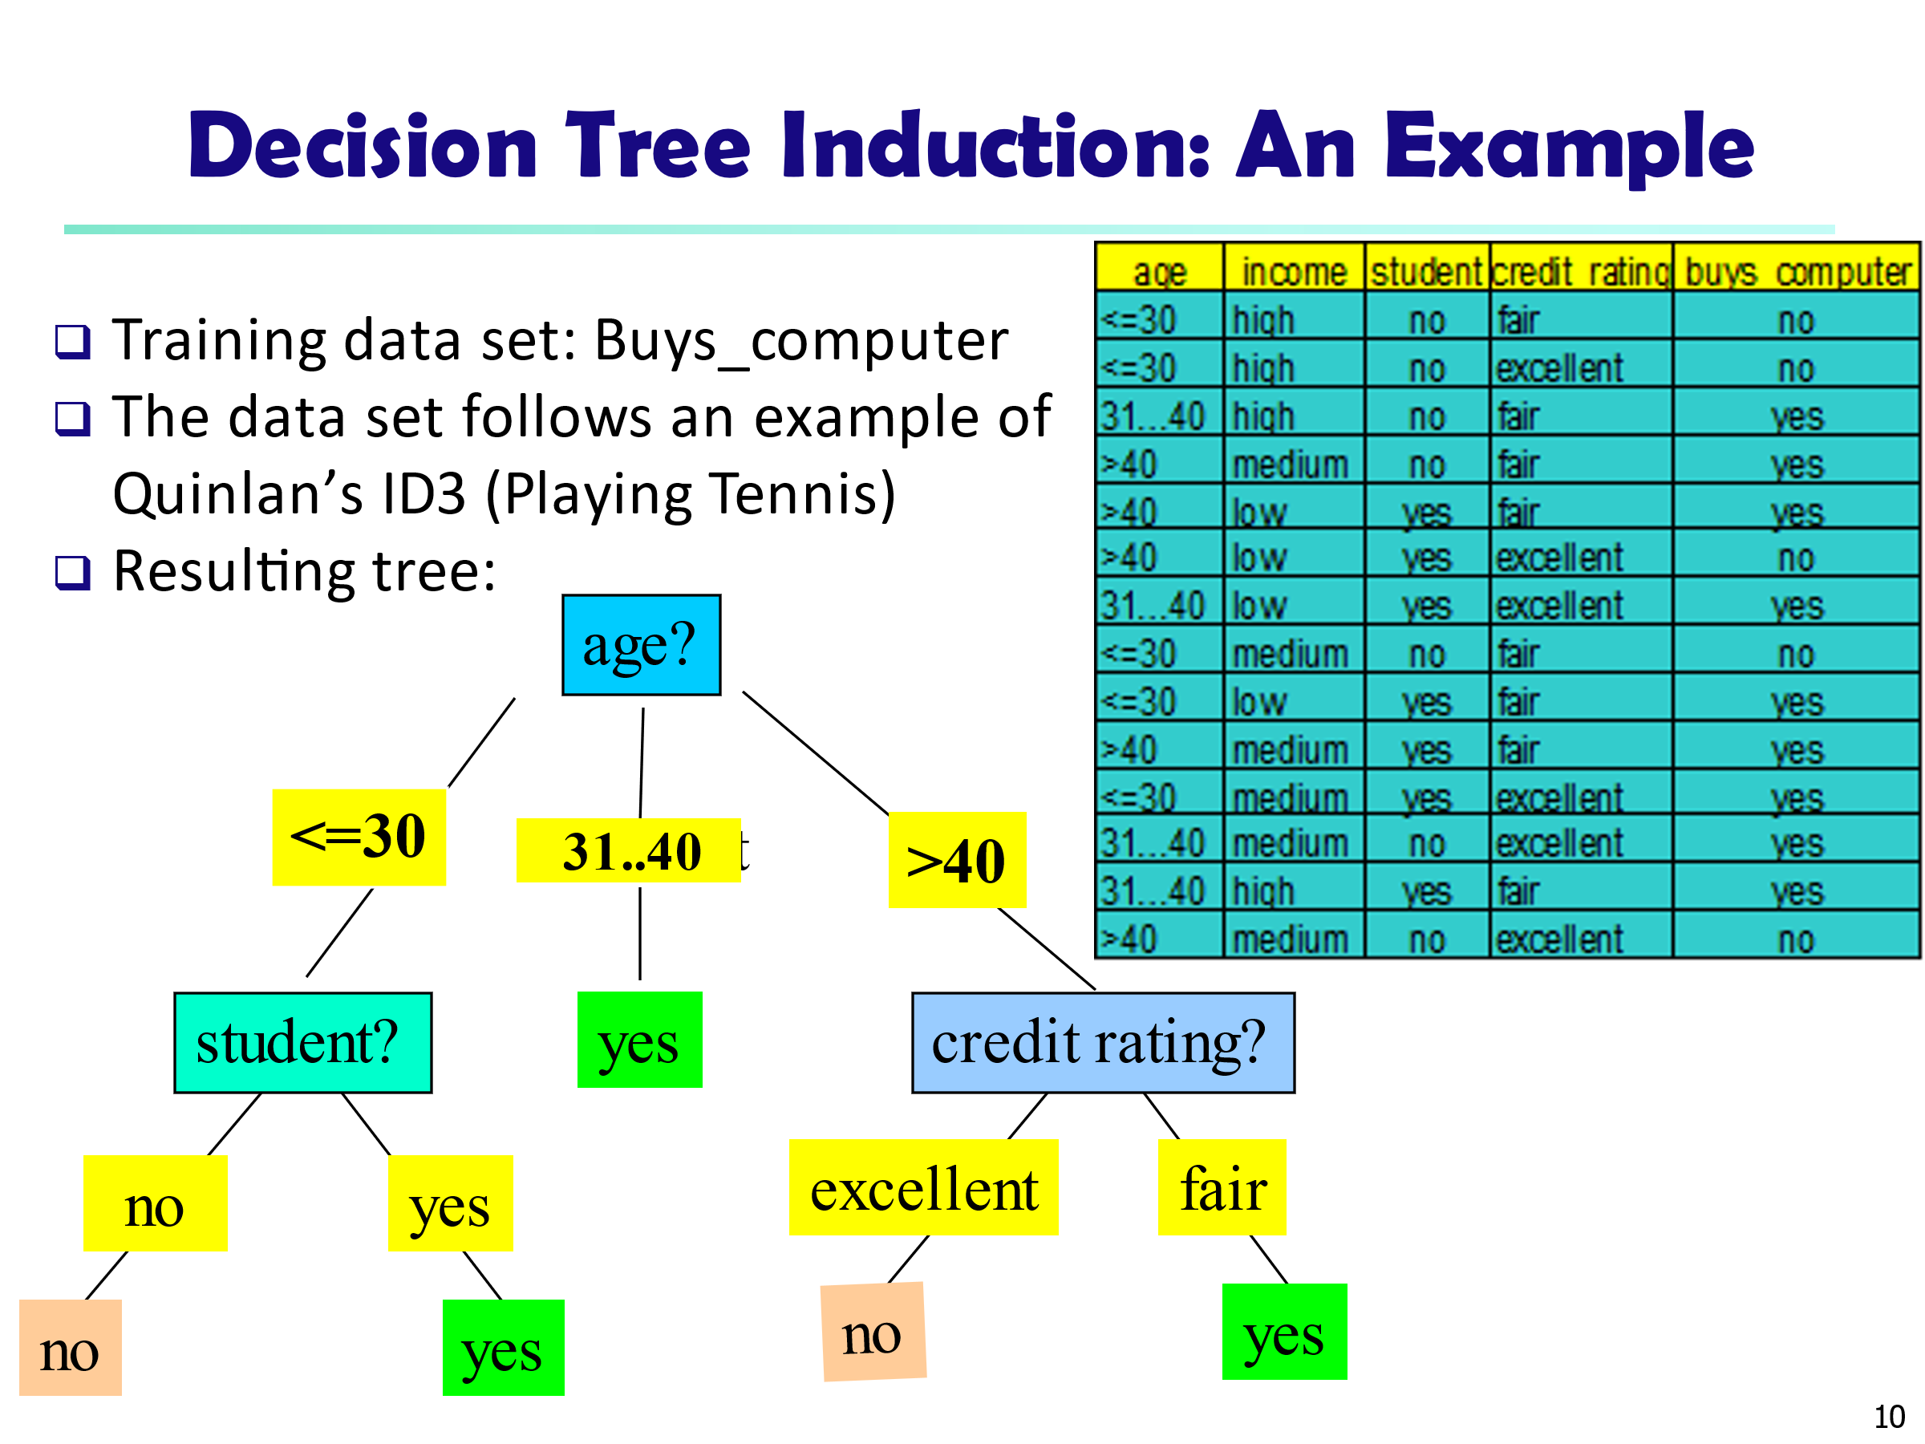

Data to be classified:

X = (age <=30,

Income = medium,

Student = yes

Credit_rating = Fair)